Individual assesment one :

Part 1 :

1a)

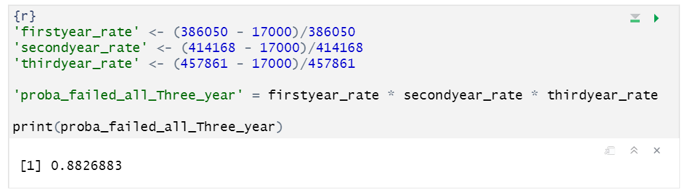

1b)

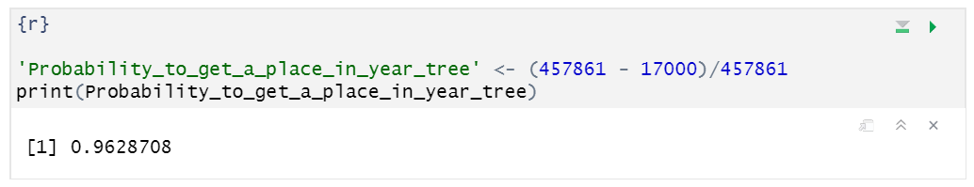

Part 2 :

2a) The most likely outcome of the business venture is a return of 3000 dollars.

2b) The venture is likely to be positive, by computing the weight of the positive and negative values we can see that the positive values are more likely to appear.

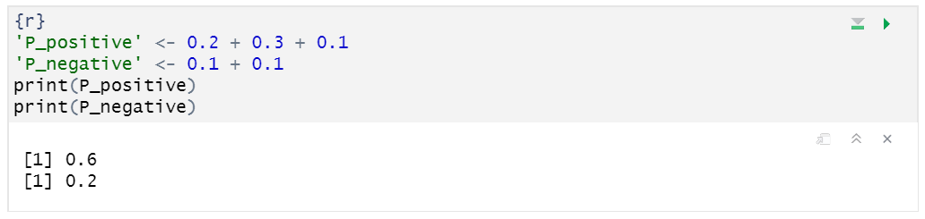

2c) The mean earning of the distribution is 600 dollars.

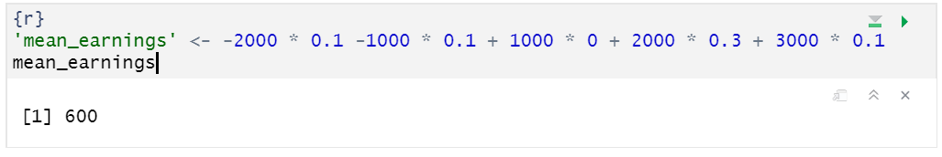

Part 3 :

1. Pizzza recipee : 250g flower + 150g Cheese + Tomato sauce

Distribution of 500g of flower (0.5, 0,31^2) for 250g (0.25,0.31^2)

Distribution of 150g of cheese (1, 0.49^2)

Tomato sauce (0.5,0)

To get the distribution of the ^rice of the pizza, we therefore add upp each mean and variance.

Mean price of pizza (0.25+1+0.5)= 1.75

Standard deviation of price of pizza (0.31+0.49+0) = 0.8

The distribution of the total price of a pizza is therefore (1.75,0.8­^2)

1. The probability of the price being higher that 2.8 dollars is 45%

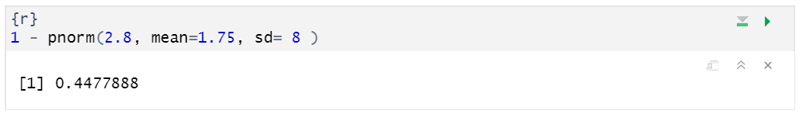

**Part 4**

**a)**

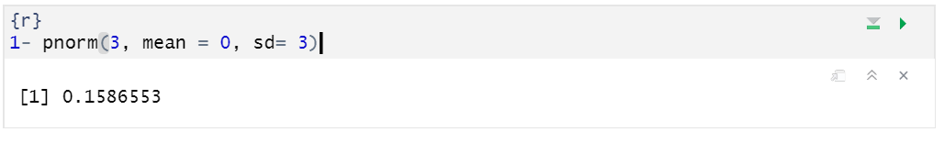

**b)**

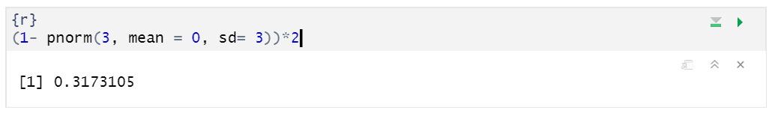

**C)**

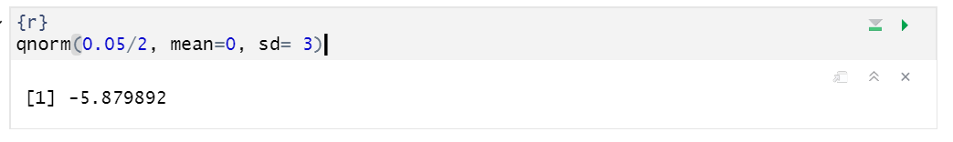

**D)**

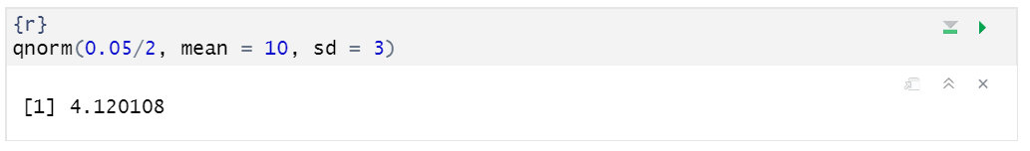

**Part 5**

1. Because n > 30 we can use the central limit theorem,

The probability distribution is N (279, (90/10)^2)

Let’s compute the probability that the sample mean will be less than 250 000

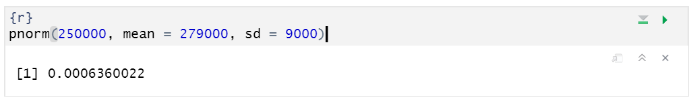

1. n = 100, mean = 279 000, SD = 90 000

1st calculate the degree of freedom:

DF = n-1 = 99

2nd we use a T table to figure out our t value

T value = 1.984

3rd we calculate the standard error :

SE = SD/squareroot(n)

SE = 90000/squareroot(100) = 9000

5th we calculate upper and lower value

Upper = mean + SE * Tvalue = 279 000 + 9000 * 1.984 = 296856

Lower = mean – SE * Tvalue = 279 000 - 9000 * 1.984 = 261144

The 95% confidence interval is therefore [261144,

296856]

1. n = 100, mean = 279 000, SD = 90 000

1st calculate the degree of freedom:

DF = n-1 = 99

2nd we use a T table to figure out our t value

T value = 1.29

3rd we calculate the standard error:

SE = SD/squareroot(n)

SE = 90000/squareroot(100) = 9000

5th we calculate upper and lower value

Upper = mean + SE * Tvalue = 279 000 + 9000 * 1.29= 290610

Lower = mean – SE * Tvalue = 279 000 - 9000 * 1.29= 267390

The 95% confidence interval is therefore [26390,

290610]

1. We can see that the 95% confidence interval is the biggest. comparing both intervals highlights the fact that the bigger the interval, the bigger the confidence. As are estimation becomes smaller and closer to the mean, the probability of being in that estimation becomes smaller.
2. ????

6)

Befoore we start, we calculate the mean, the length and the standard deviation of the

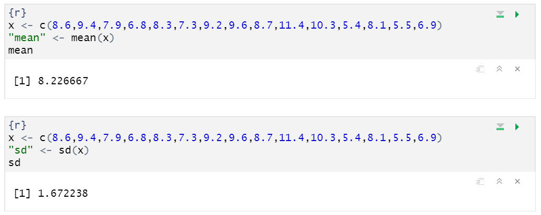

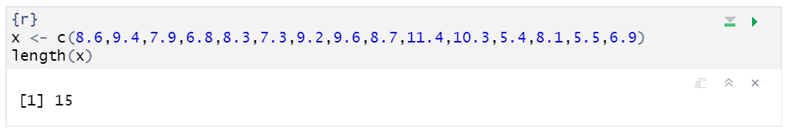

calculate the degree of freedom:

DF = n-1 = 14

3rd we use a T table to figure out our t value

T value = 1.29

4th we calculate the standard error:

SE = SD/squareroot(n)

SE = 90000/squareroot(100) = 9000

5th we calculate upper and lower value

Upper = mean + SE * Tvalue = 279 000 + 9000 * 1.29= 290610

Lower = mean – SE * Tvalue = 279 000 - 9000 * 1.29= 267390